**CNT 5805 Final Project Preliminary Report**

1. **Project Team number (already assigned in WebCourses) and Project Title (you decide)**

Project Team number: 9

Title: Chord Progression Network Analysis of Ray Charles Jazz songs.

1. **Project Member Names:**
   1. Gehan Velivitiya
   2. [Juanita Ramirez Villanuev](https://webcourses.ucf.edu/courses/1439237/users/4422187)a
2. **Briefly describe the data you want to analyze to the extent that anyone can become familiar with it.**

In this project, the objective is to understand patterns of chord progressions in Ray Charles songs. To do that we want to construct a network in which nodes would be chords and the links connect two consecutive chords in a song (origin chord to the destination chord), this network is a directed network, and the weight indicates the number of songs in which that chord transition occurred.

We will be creating our own dataset. The song's chords were taken from <https://www.e-chords.com/ray-charles>, and the chords will be extracted from the files, 88 songs were collected (site's total number of not-repeated songs) with different keys, and translated to the keys C or it’s relative minor Am to preserve the structure of each song in the network.

In an article related to Network Analysis of Chord Progression[1], the network consisted of 149 jazz songs, 241 nodes, and 6520 links. In our dataset there are 88 songs, 183 chords and 2525 links. To perform a balanced comparison we will randomly choose 88 songs out of the 149 jazz songs from the general network and produce a new network.

The features/fields of this dataset are:

1. Key of the song: the chord (or note) that the song is centered around.
2. The name of the song.
3. The chord progression of the song (i.e., each chord is stored in a column).
4. **Explain your motivation for analyzing this data: Why would you want to analyze this data? Do you have experience in this area of study?**

Music is connected with sciences such as mathematics, physics, and Neurosciences, yet the information available from a network science perspective is scarce. This project seeks to understand music from a structural perspective and represent its components in graphs.

* Music is composed of 12 notes, the "minimal" unit (in western music).
* Sequences of notes form scales, a melodic structure.
* Two notes played simultaneously make consonant or dissonant sounds, that creates a type of relationship between notes.
* Three or more notes played simultaneously make chords which form the structure of a song.

What is the connection with network science? One of the observed connections is the importance of cycles.

1. Music theory:

In mathematics, the notes are equivalent to the group $Z_{12}$, a graph in which each note has two neighbors, and each edge represents a unique distance the semitone (see Figure 1):

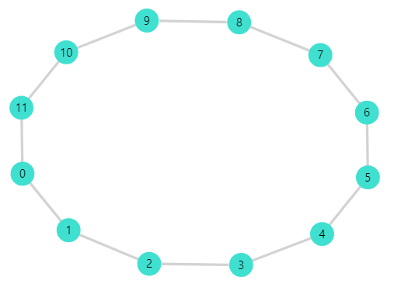

*Figure 1: $Z_{12}$*  graph. Distance between two nodes is equivalent to one semitone, the edges represent a distance.

The concept of scales can be seen as a cycle, a scale is a set of positive distances that add to 12 (12 is equivalent to the class of 0 in $Z_{12}$, then it is a cycle). For example, the Major Scale with distances: 2-2-1-2-2-2-1 and Minor Scale with distances: 2-1-2-2-1-2-2, note that the above graph of notes forms a scale called the chromatic scale.  
In this graph it is observed the major scale starting at node 0 and a relative minor scale starting in node 9 (see Figure 2).

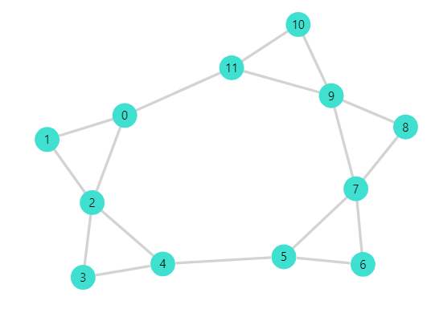

*Figure 2: Major and Minor scale graph. This is a modification of Figure 1. Major scale pattern: starts at node 0 and connects nodes with distances: 2-2-1-2-2-2-1, 0+2= 2, thus zero is connected to two, then 2+2= 4 and two is connected to four, the procedure is repeated following the corresponding distances until the starting node is reached.*

This scale structure generates new distances that will affect the chord progression network.

**The circle of fifths:** A famous cycle in music is the circle of fifths, in which each note is separated by a distance of 7 semitones, obtaining the following graphs:

A regular graph that contains the circle of fifths and the graph of the notes, which forms a symmetric figure(see Figure 3)

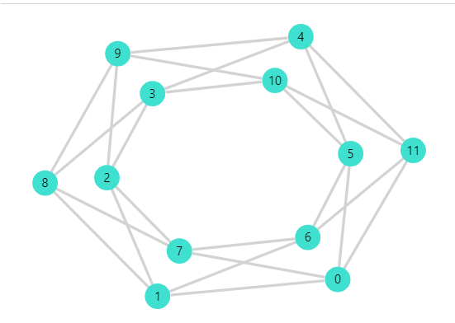

*Figure 3: Circle of fifths. This is a modification of Figure 1, and connects nodes with distance 7 under module 12, for example 10+7 mod 12 = 17 mod 12 = 5, then 10 is connected to 5.*

The circle of fifths that among its several uses in music also describes relationships between chords. (In music chords and notes have the same name, even though this generates confusion, it permits to interpret this graph in different contexts: notes, scales, and chords)

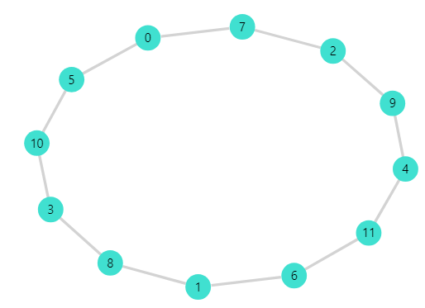

Figure 4: *Alteration of $Z_{12}$ scale in a circle of fifths, nodes are connected with distances of 7 semitones.*

1. Motivation:

Considering the facts mentioned in section (a) above, our motivation is to do a thorough network analysis of chord classes and to define a methodology to analyze chord progression structures for different singers. Chord progressions form the backbone of music, and they contribute to the overall sounds, mood, and emotional sense of music and are crucial in understanding the style of music and appreciating it. Progression structures differ from genre to genre which makes them distinguishable and unique. By constructing a network for this we will have the capability to look at the big picture of how certain melodies in music become appealing than others.

Due to the richness in theory, the variety and the large number of chords found in jazz, this genre shows some complexity. Although the melody is in chromatic scale and everything seems to sound disorderly or improvised which is one of the characteristics of jazz, the chords are in major and minor scales, which govern the melody and the structure of the songs.

Ray Charles is one of the most influential artists and a popular singer. Having that in mind we decided to concentrate our research specifically on his contributions to Jazz. By doing so we can thoroughly study his structure of music and draw meaningful conclusions. Also, our goal is to construct this analysis as a model in network science which can be extended to study other artists. With our knowledge of music along with the help of a few experienced individuals we believe we can do a meaningful and insightful analysis.

1. **Describe what specific research questions your analysis will address. In other words, what do you want to prove or disprove? You should typically have four-six questions.**
2. Does Ray Charles have a preference for chords used in his songs?
3. Nodes and link attacks could represent failures in the instrument or the person playing it. Can the chord progression network show us why some mistakes in songs go unnoticed? What is the robustness of the network?
4. Does Ray Charles have a unique music style compared to other artists?
5. In the structure, why do more important links (larger weights) appear?
6. Are there any communities? Is there homophily? Is it possible to explain those communities using music theory?
7. Describe any data cleansing you plan to do
8. Our data is in .txt format where each song has a .txt file with lyrics and chords. Therefore, we have to separate chords from lyrics and extract them.
9. Since the same link between nodes (i.e., Links between two consecutive chords) could appear multiple times in the same song, therefore we have to fetch the unique links only.
10. All notes of songs form a star-shaped structure (Figure 2) that could be rotated for each song, to preserve the relations between notes, all the structures were rotated to have the same orientation, this is called transposition of chords.
11. Afterwards unique chords have to be extracted and generate id’s for each chord.
12. At last two .csv files(node.csv & edge.csv) need to be created in the Gephi spreadsheet format.
13. The notation of chords can vary, it is necessary to change equal chords to a common notation.
14. **Are you working with any entities outside of our classroom on this project (e.g., professors, businesses, universities, labs, governments)? If so, please explain**

Yes, we are planning to work with a few individuals who are in jazz music. We formerly need help in certain aspects of jazz theory in conducting our research successfully.

**Bibliography**

Bien, N., Carrol, H., & Ramachandran, N. (n.d.). Network Analysis of Chord Progressions in Rock and Jazz music. Retrieved from [*http://snap.stanford.edu/class/cs224w-2018/reports/CS224W-2018-94.pdf*](http://snap.stanford.edu/class/cs224w-2018/reports/CS224W-2018-94.pdf)

The Framework of Music Theory as Represented with Groups, Ada Zhang, June 4, 2009. [*https://sites.math.washington.edu/~morrow/336_09/papers/Ada.pdf*](https://sites.math.washington.edu/~morrow/336_09/papers/Ada.pdf)